# INTRODUCTION

* 1. Overview

Whereas electricity consumption represents the amount of electrical energy that has been consumed over a specific time, in units of Wh (or kWh), electricity demand represents that rate at which electrical energy is consumed for a needed output rating, in units of W (or kW).

* 1. Purpose

People use electricity for lighting, heating, cooling, and refrigeration and for operating appliances, computers, electronics, machinery, and public transportation systems.

Annual electricity consumption per capita serves as an important measure of a country's electric power development. Generally speaking, electricity consumption grows faster when the industrialization process develops quickly and goes down rapidly when industrialization is completed or near completion.

1. **Problem Definition & Design Thinking**
   1. Empathy Map

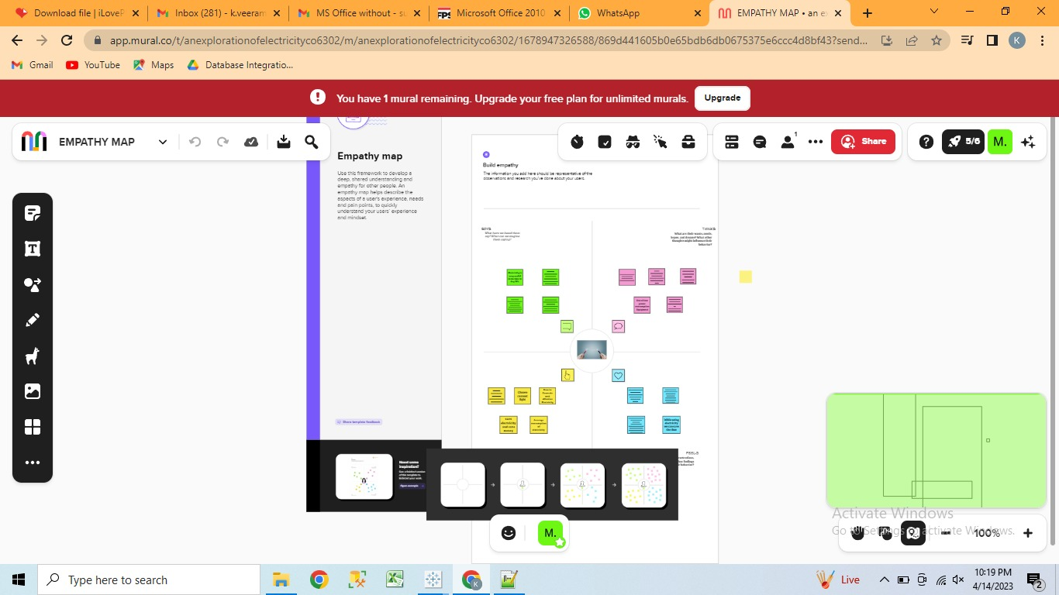

* 1. Ideation & Brainstorming Map

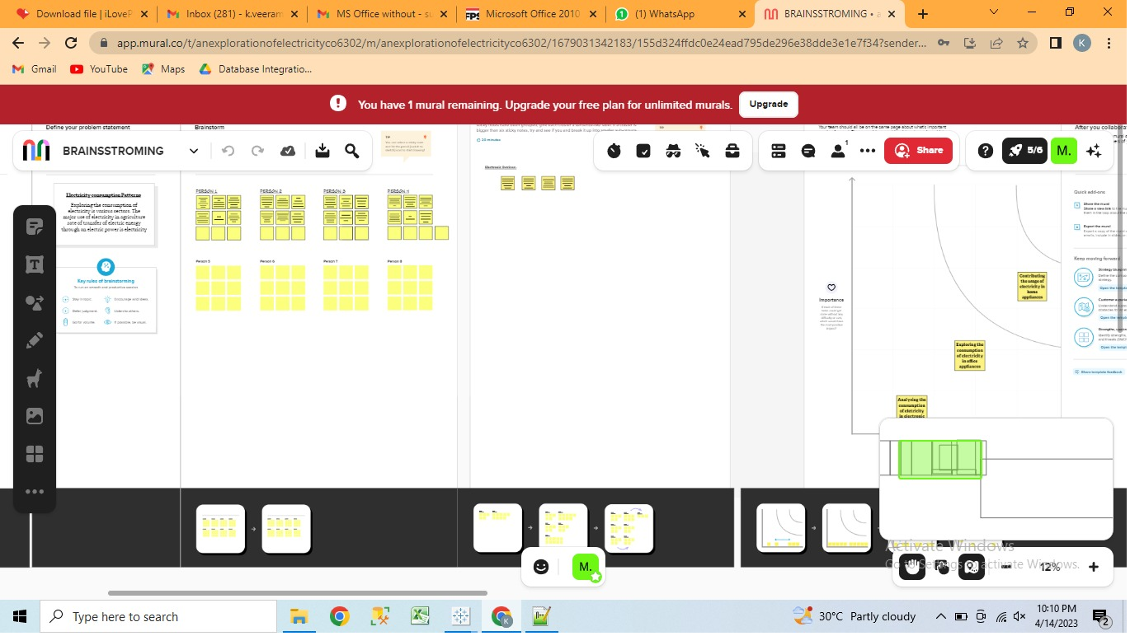

# RESULT

Dashboard

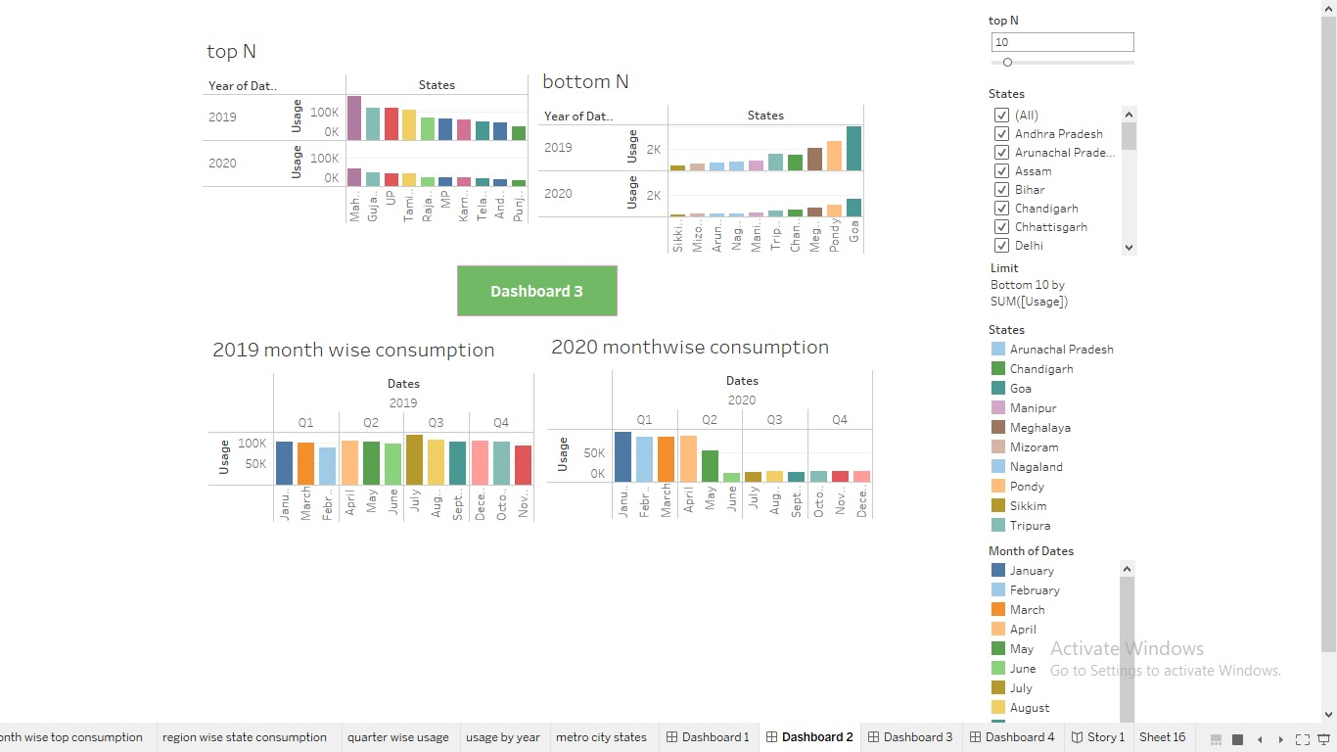

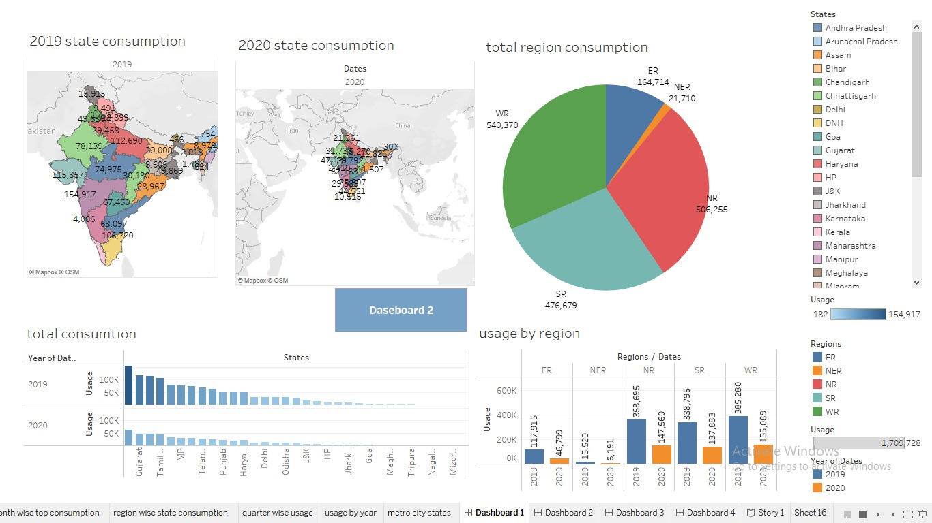

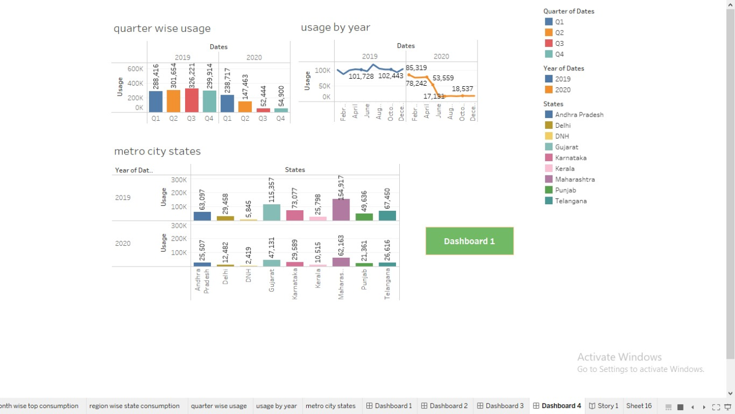

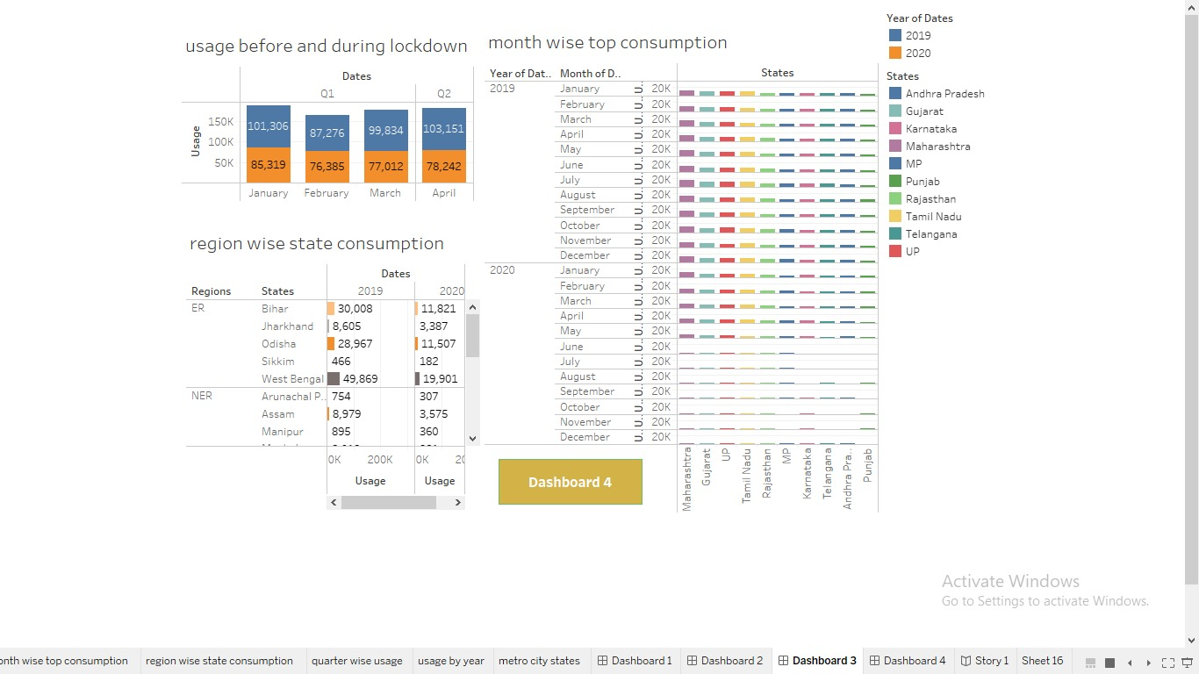

# Story

# 

# 

# 

# ADVANTAGES & DISADVANTAGES

Advantages of Electricity :

* It is a clean, safe, cheap and convenient source of energy
* Lower maintenance cost
* More efficient
* No tailpipe emission
* We all know that it can be set up in many sizes
* It doesn't require as many employees
* Reduces greenhouse emission
* Makes barely any pollution compare to other ways of creating or generating electricity
* Relatively low maintenance cost
* Hydroelectric station are inexpensive to operate
* Hydroelectricity produces no gas emissions or waste
* A station can operate and run for long periods of time
* It is renewable

Disadvantages of Electricity:

* More expensive than gasoline.
* Loss of fish species.
* Sometimes messes up wildlife.
* Dependent on precipitation.
* More power plants and more pollution.
* Damming can cause loss of land suitable for agriculture as well as recreation.
* Cost for construction.
* Change in river or stream quality.

# APPLICATIONS

* Air conditioning and heating: 46 percent.
* Water heating: 14 percent.
* Appliances: 13 percent.
* Lighting: 9 percent.
* TV and Media Equipment: 4 percent.

# CONCLUSION

It should be saved because it's not at all free. Energy conservation is the effort made by us to reduce the consumption of energy by using less of an energy service or using reneuable energy..

# FUTURE SCOPE

In the Stated Policies Scenario, global electricity demand grows at 2.1% per year to 2040, twice the rate of primary energy demand. This raises electricity's share in total final energy consumption from 19% in 2018 to 24% in 2040. Electricity demand growth is set to be particularly strong in developing economies.

# APPENDIX

A. Source Code

Attach the code for the solution built